# Assignment Name: CSS Grid Fall 2020

## Due Date: See Canvas

## Goals:

You have been given image files, a starter CSS file, and an HTML file which has all of the required content to recreate the provided screenshot. Use only CSS to achieve the changes - do not change the html file.

## Objectives:

1. Demonstrate ability to use CSS Grid for layout of page content
2. Demonstrate ability to code a working “Skip to Content” link that is not displayed on the screen until it is in focus.
3. Demonstrate ability to use media queries to adjust how page content displayed on different devices.

## Resources:

<https://github.com/UMSIComplexWebDesign/homework_4>

You are provided with a repo that contains the necessary html file, a starter css file, and a screenshot of the final results. You will need to edit the css file to transform the original page to one that resembles our example using the outlined CSS styles below. *Remember, resource files often have a few bugs in them to provide an opportunity to debug and problem-solve*. The changes will be small.

## Requirements:

***Note, the css code has comments to guide you through these requirements. In some cases the requirements may already be fulfilled in the partial CSS we supplied.***

1. All files and folders present, HTML file and CSS stylesheet in proper format, no styles in HTML. **DO NOT MAKE ANY CHANGES TO THE HTML BODY**. Do not add any classes or ids.
2. Remove the underline from all links in the navigation.
3. When the mouse hovers over any link in the navigation add an underline under the link.
4. The “Skip to content link” (the link within the skip class) should have the following styles on all screen sizes
   1. The link is positioned 40px above the top of it’s parent element (it is hidden by default).
   2. When the link is in focus it is positioned even with the top of it’s parent (so it is visible only when in focus.)
5. Any element in focus should have a 2px solid border on all sides.

### **The following specifications are for the mobile view:**



1. .container class uses grid:
   1. Three columns: 1fr 5fr 1fr
   2. Five rows: all auto.
   3. Gap 15px between rows;
2. header element:
   1. Spans all of the columns
      1. Done for you, check how
   2. Begins on 1st row and spans 1 row
      1. Done for you, check how
   3. Header uses header.jpg as a non-repeating

background image with parallax effect

1. .about, .method, .clients, and .contact:
   1. Begin in 2nd column and span one column
   2. Begin on the 2nd, 3rd, 4th and 5th rows

respectively and each spans one row.

1. The .about-image, .method-image, .clients-image,

and .contact-image elements:

* 1. Span all of the columns.
  2. Have a **maximum height** of 700px
  3. Hide any content that goes outside their

grid cell.

* 1. Begin on the 2nd, 3rd, 4th and 5th rows  
      respectively and each spans one row.

1. .text-block is centered horizontally and vertically.

### 

### **The following specifications are for the desktop view (windows of 800px or greater)**

1. Move the navigation so that the nav is aligned to the other side of the window and centered vertically.
2. container class uses grid with
   1. Five columns: 50px, auto, 500px, auto, and 50px
   2. Five rows: 400px, 400px, 400px, 400px, and 400px.
3. The .about, .clients, method-image,.contact elements:
   1. Begin in the third column and span two columns
4. The .method, .contact, .about-image, and .clients-image:
   1. Begin in the second column and span two columns.

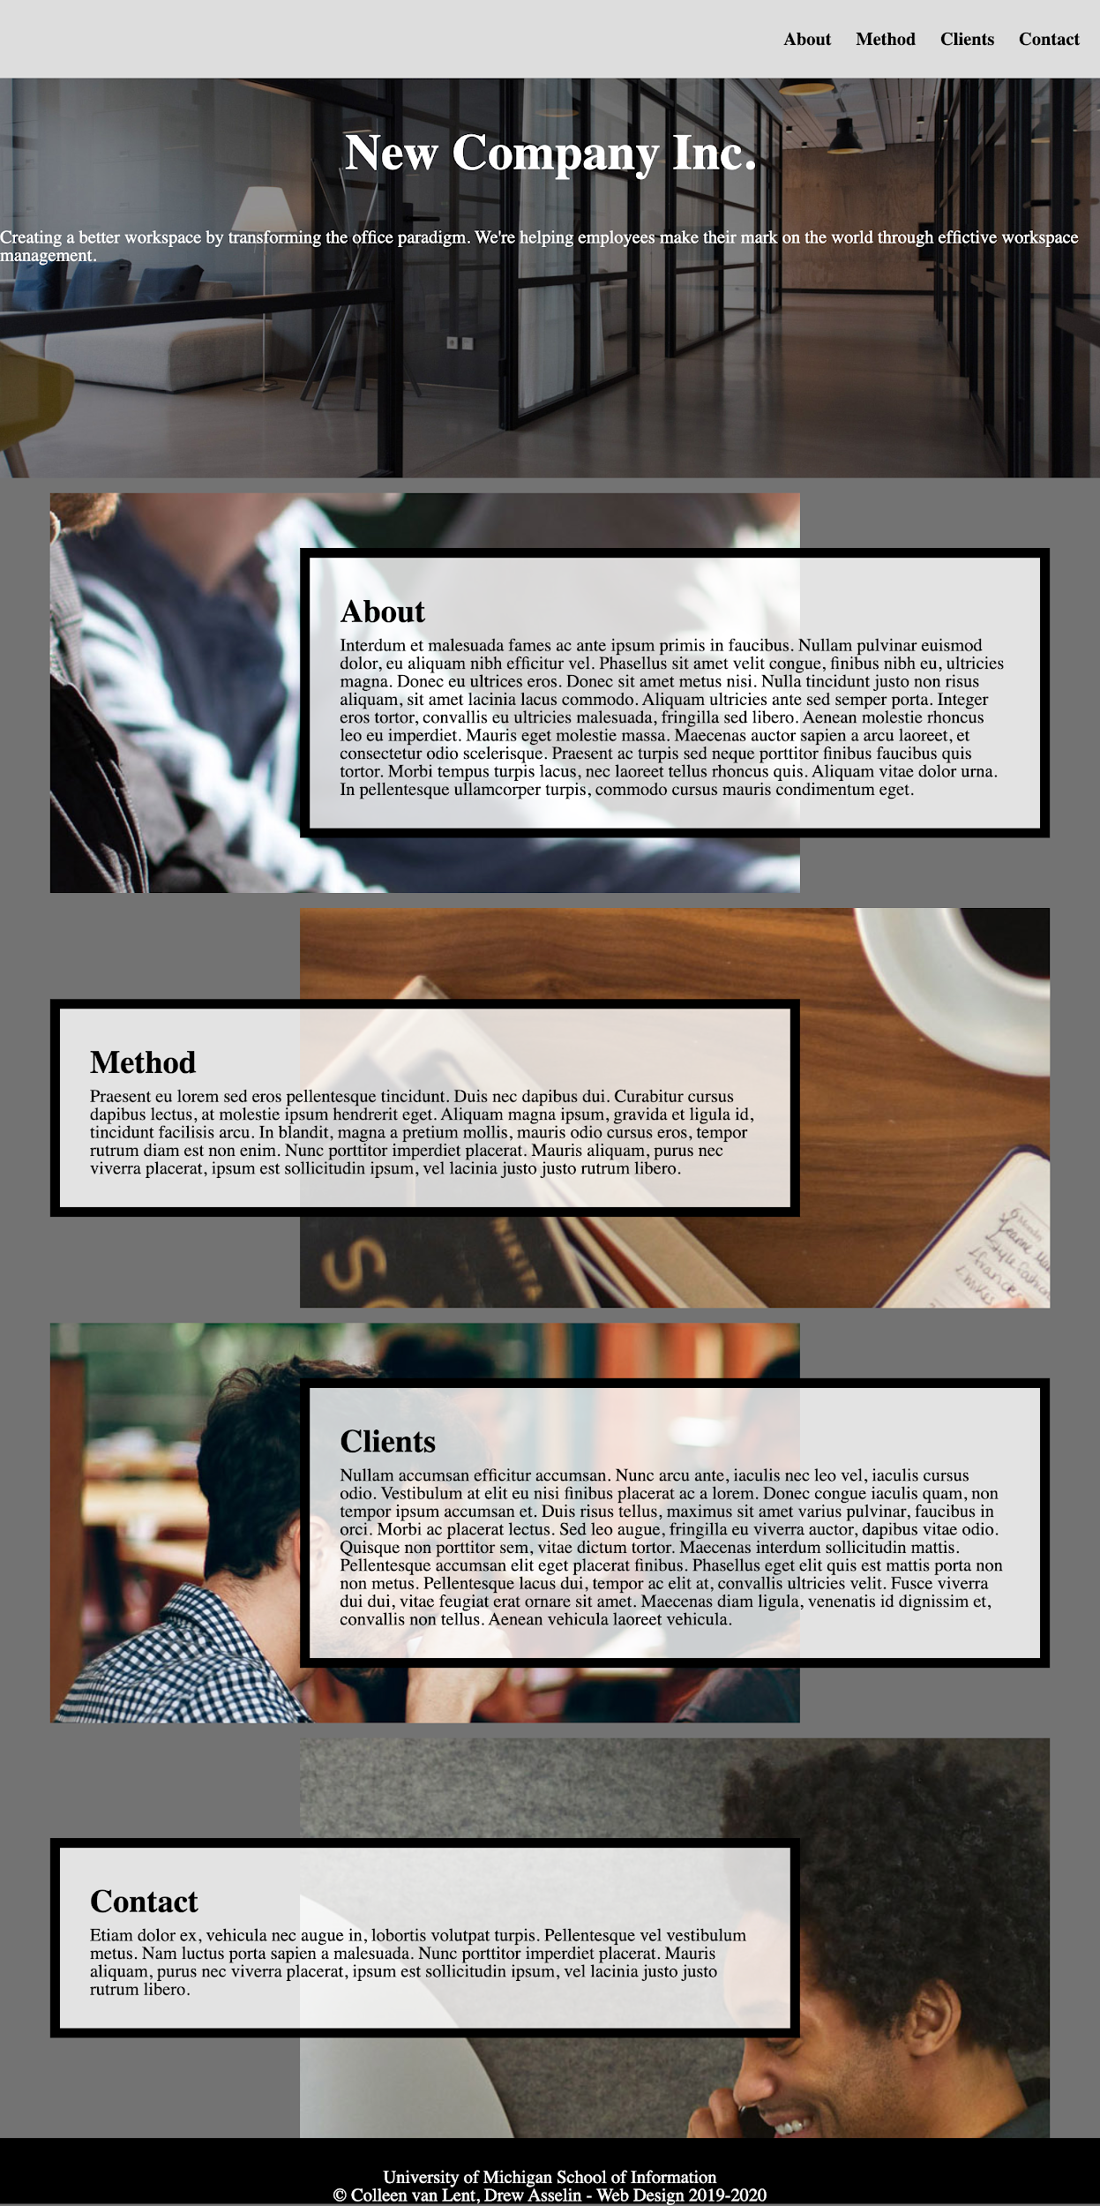

## Tips!

1. Start with the css file and look for the places you should.
2. ***Get the mobile view complete before you start the desktop view.***
3. If your rules cascade correctly, you should have fewer selectors in the desktop view

## Submission Requirements:

1. Submit a link to the page - We want to see the deployed page, not the code.
2. There are no supplementals for this homework.

### 